**Table of Contents:**

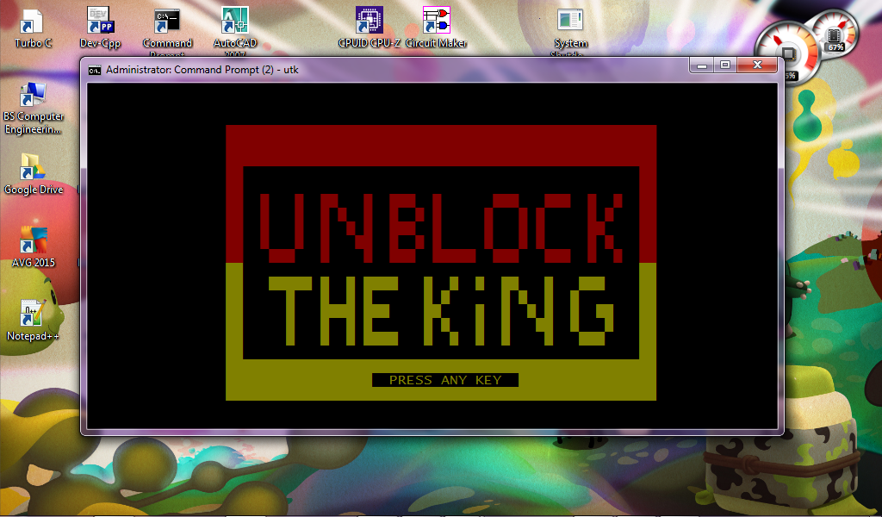

Introduction about the Application - 2

Procedure of Using the Application - 3

Snapshots and Codes Snippets - 4

Curriculum Vitae - 9

**Introduction about the Application:**

Unblock the King Block game challenging you to allow the red block to escape from the puzzle.Fun distraction that helps build problem solving skills.This game boost your brain power. Allows you to think even harder and harder. This really uses your brain skills and having fun at the same time

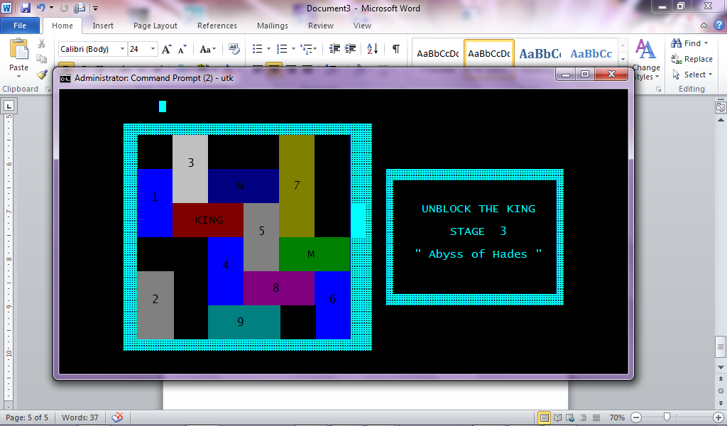

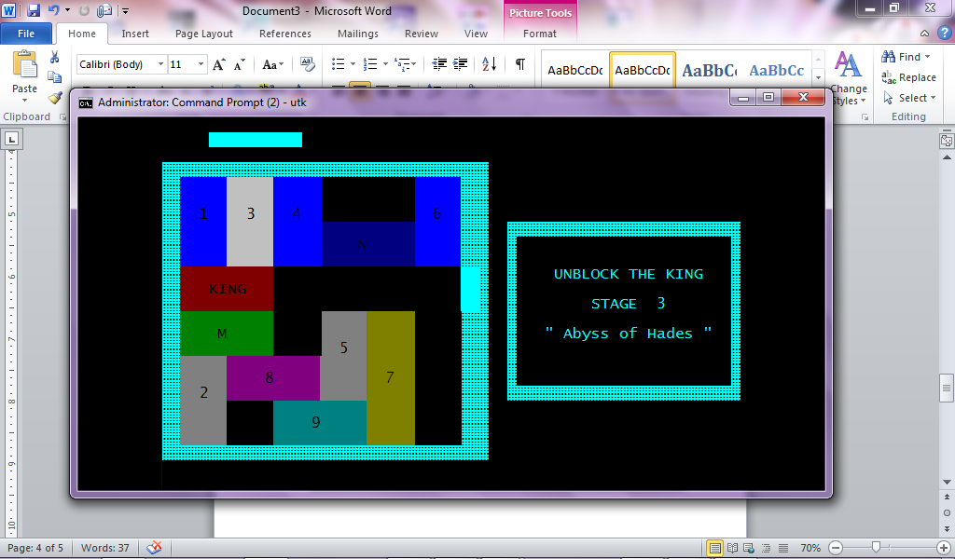

**Procedure of Using the Applications:**

You will need to move the red block to the exit. Horizontal bar can be moved from side to side. Vertical bar can be moved up and down.You need to solved in your head before you make your move.

**Flowchart:**

**Unblock the King**

Stage 1

Stage 2

Stage 3

**55 moves**

CMP CTR, 0

IF E JMP GAME_OVER

**Congrats**

**Game Over**

**Snapshots and Code Snippets:**

**Title Page**



**Game Proper**

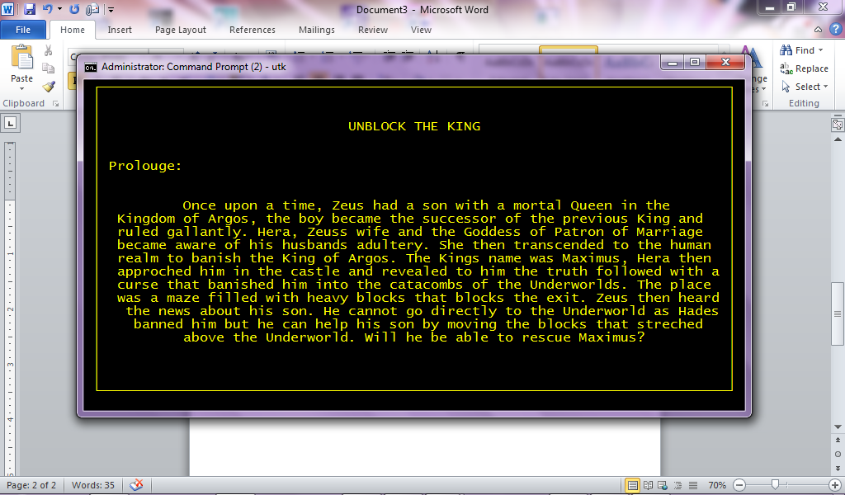

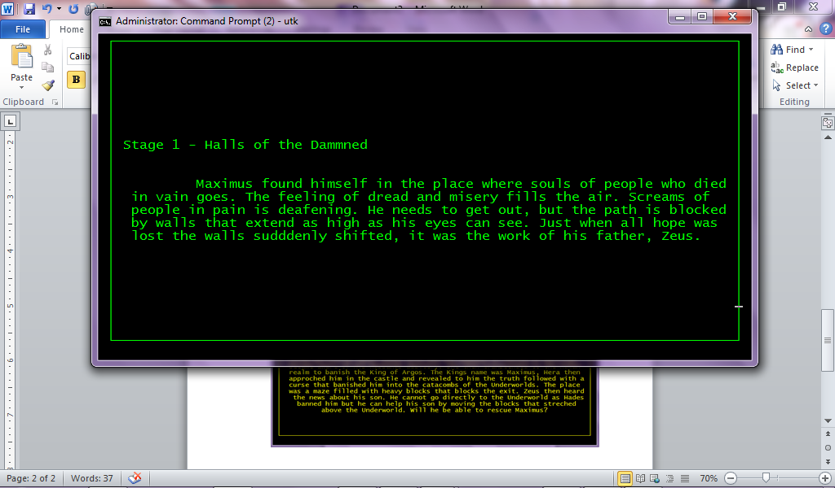

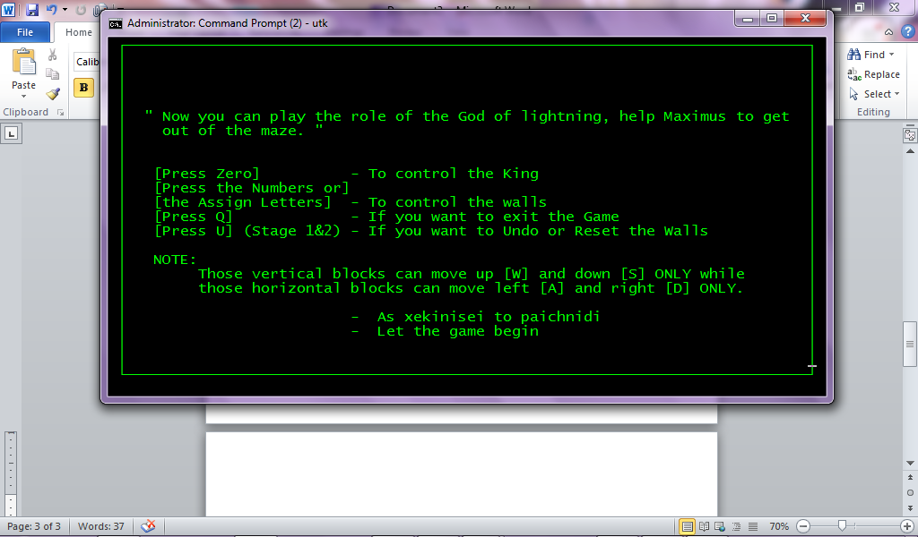

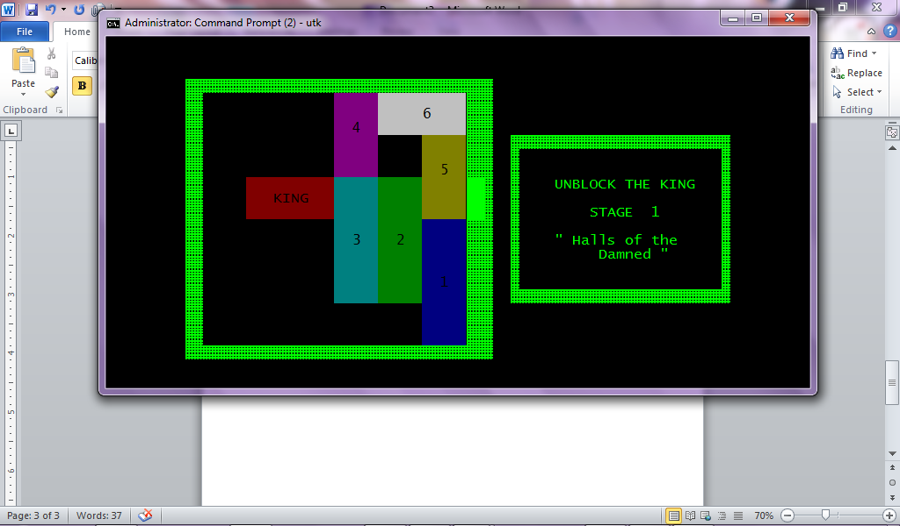

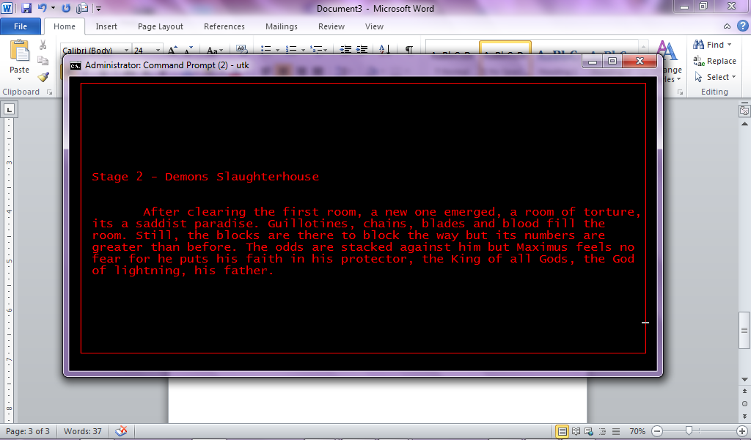

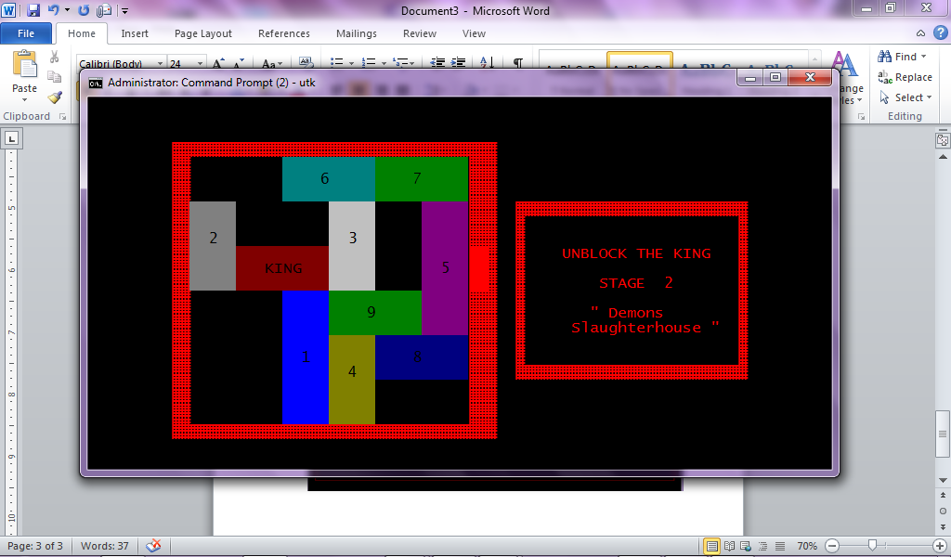

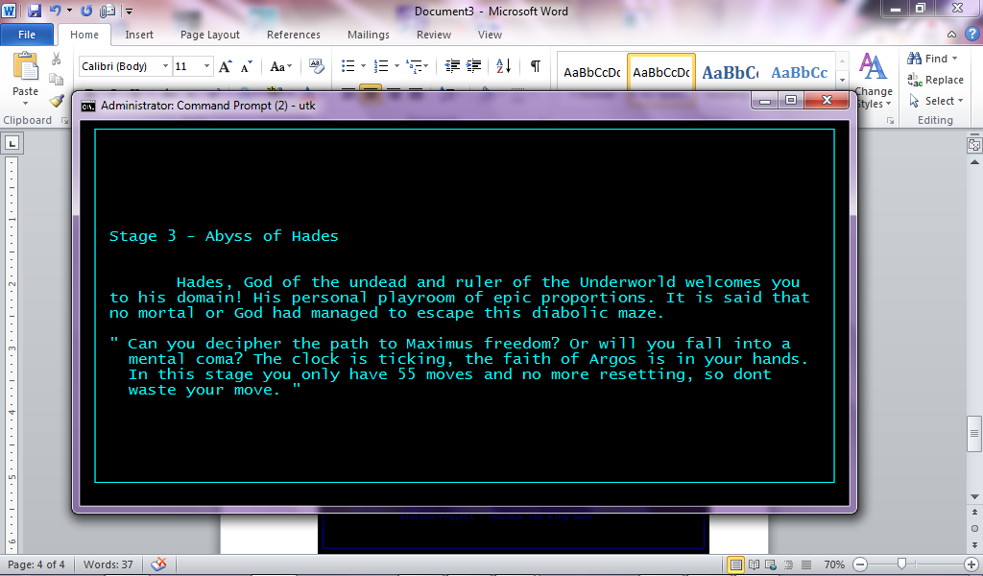

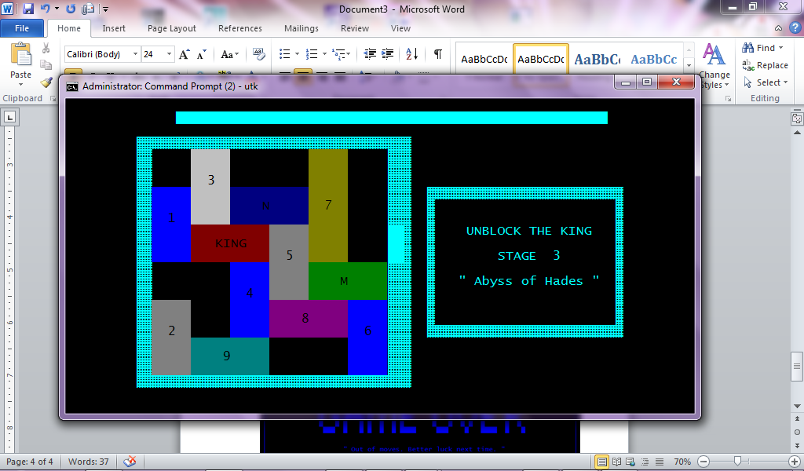



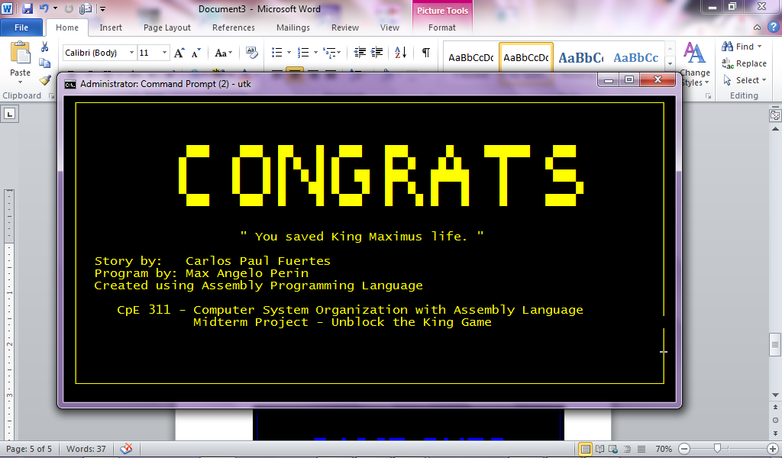



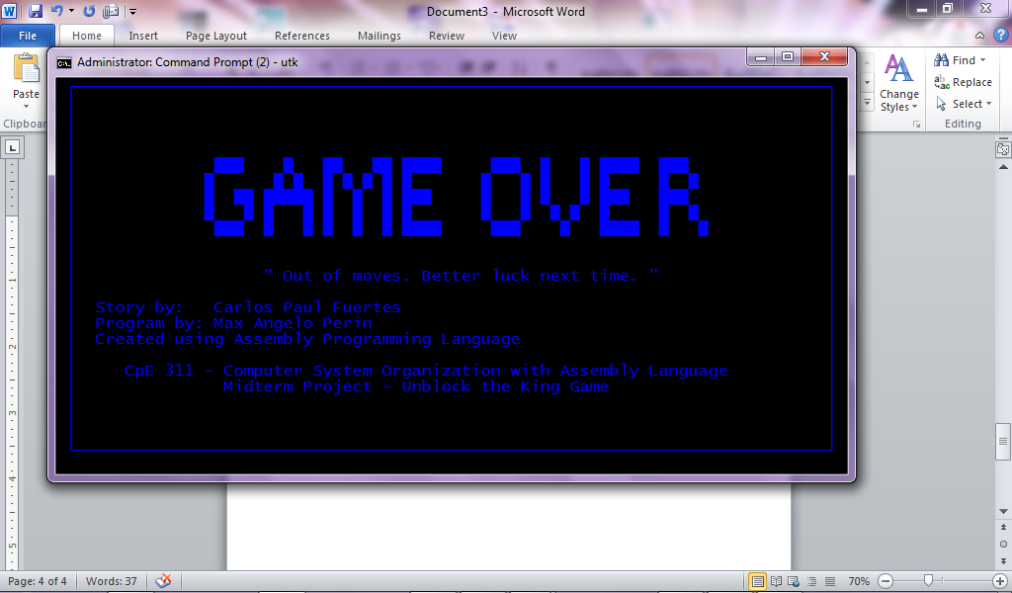

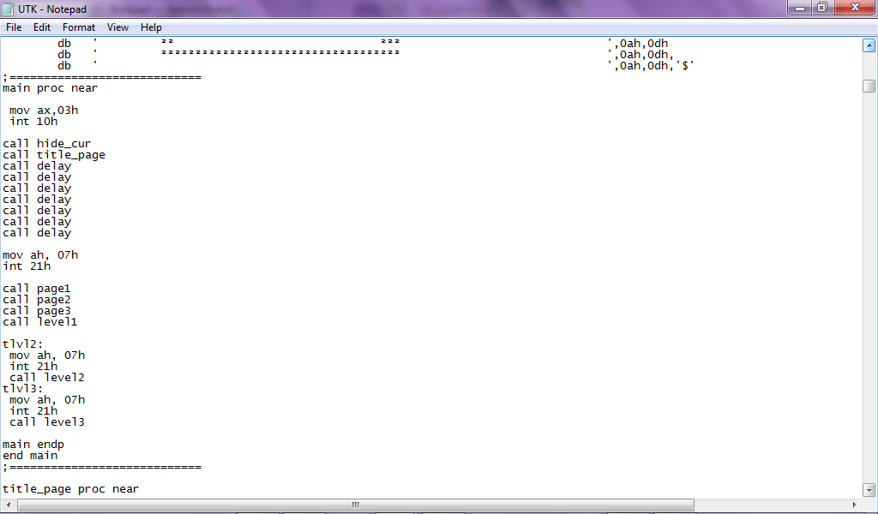 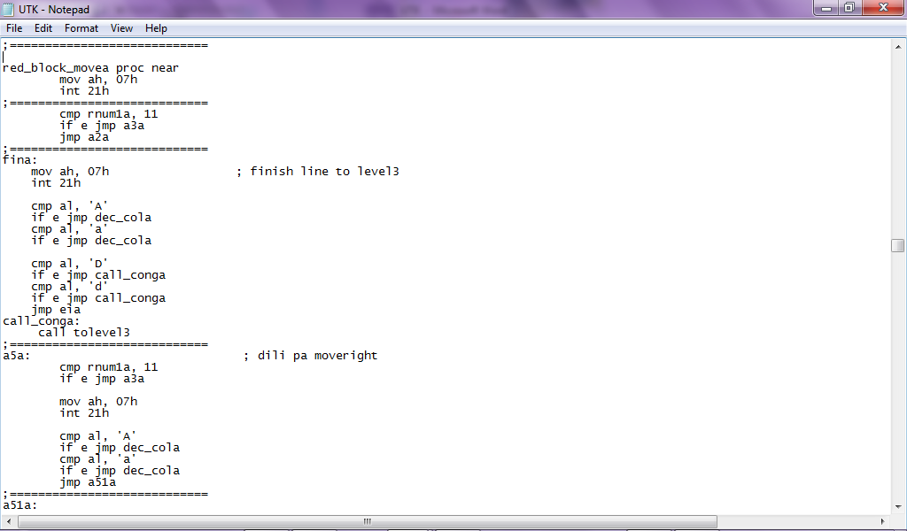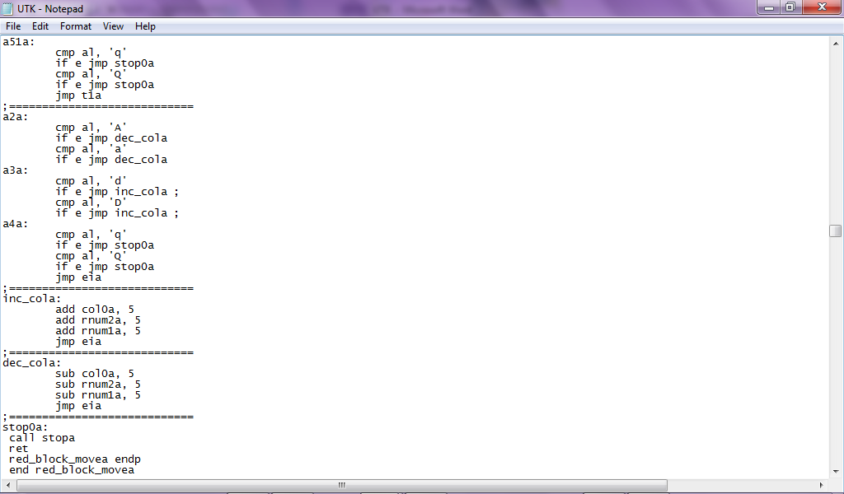

**Main Calling the Game Moving the Red Block in Stage 2**

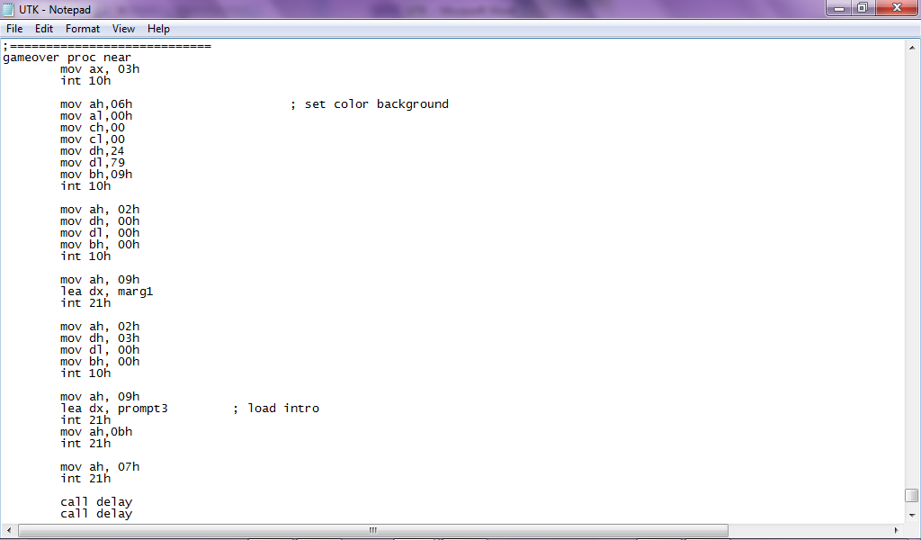 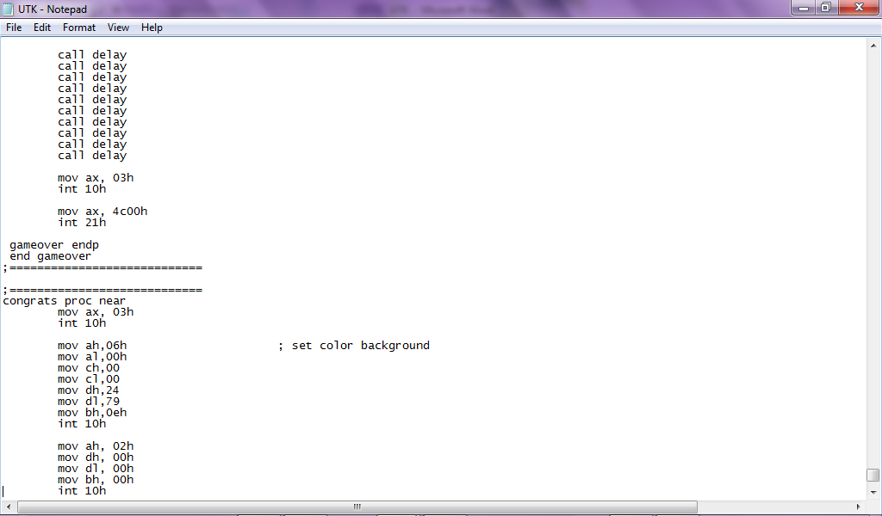 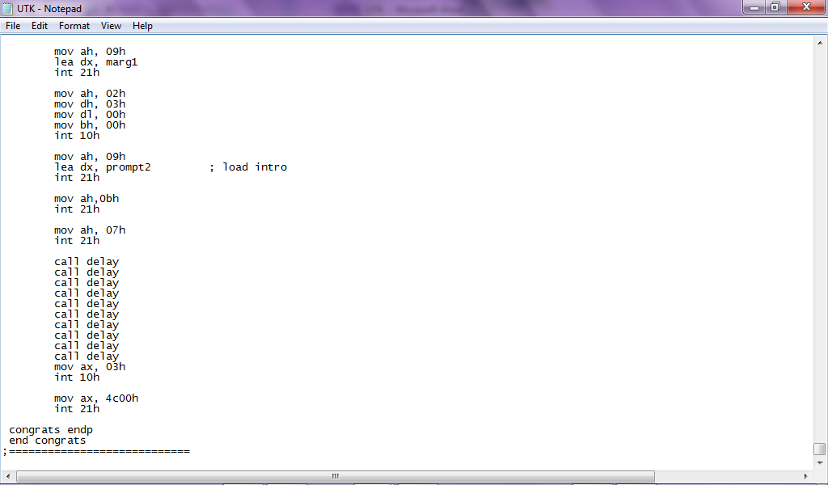

**Congrats and Game Over Code**

**Curriculum Vitae:**



**Name:**  Perin, Max Angelo Dapitilla

**Section:** BSCpE 3

**School:** BISU-Main Campus

**Address:** Taytay, Loboc, Bohol

**Nationality:** Filipino

**Languages:** English, Filipino, Cebuano

**Birthday:**  December 9, 1996

**Age:** 18

**Mobile Number:** +639087588785

**Facebook:**

facebook.com/maxangelo987

**E-mail:** perinmaxangelo@yahoo.com

**Quote:** “ The way is not in the sky. The way is in the heart. “